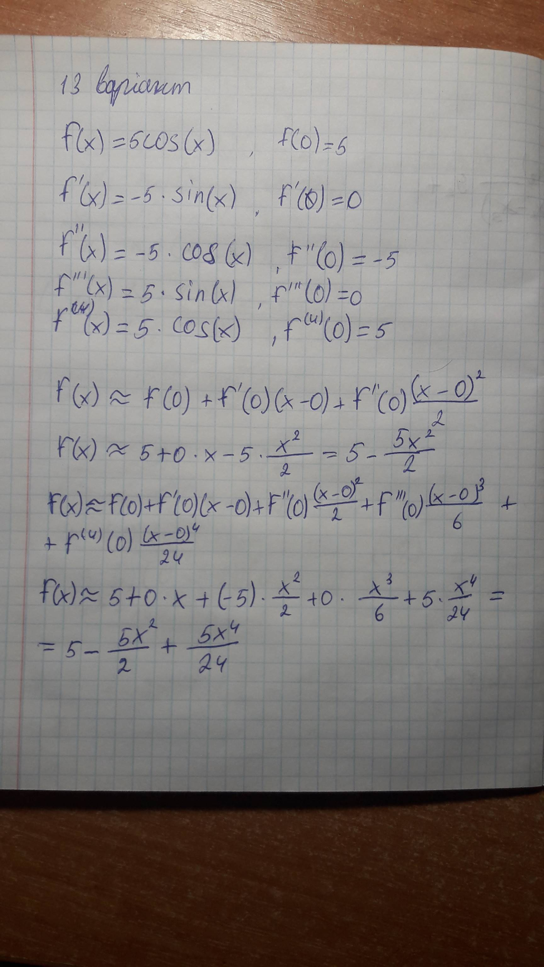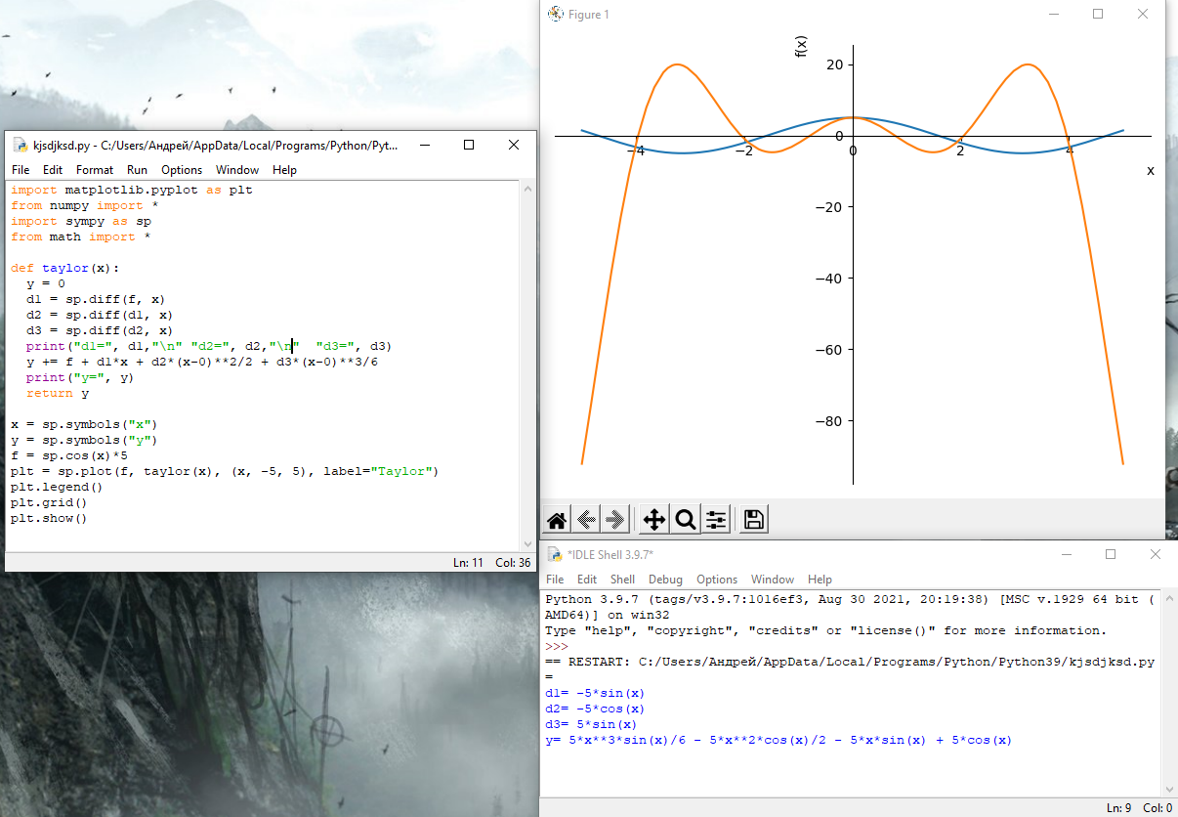

import matplotlib.pyplot as plt

from numpy import \*

import sympy as sp

from math import \*

def taylor(x):

  y = 0

  d1 = sp.diff(f, x)

  d2 = sp.diff(d1, x)

  d3 = sp.diff(d2, x)

  print("d1=", d1, "\n" "d2=", d2, "\n" "d3=", d3)

  y += f + d1\*x + d2\*(x-0)\*\*2/2 + d3\*(x-0)\*\*3/6

  print("y=", y)

  return y

x = sp.symbols("x")

y = sp.symbols("y")

f = sp.cos(x)\*5

p1 = sp.plot(f, taylor(x), (x, -5, 5), label="Taylor")

plt.ledend()

plt.grid()

plt.show()